DIRECT MARKET ACCESS FOR FARMERS APPLICATION DEVELOPMENT USING MACHINE LEARNING

*Sivaramakrishnan S*

*Department of computer science and engineering*

*Presidency university*

*Bengaluru, India*

*sivaramkrish.s@gmail.com*

*Akshay B*

*Department of Computer Science and engineering*

*Presidency university*

*Bengaluru, India*

*akshayrajaras002@gmail.com*

*Karthik m swamy*

*Department of Computer science and engineering*

*Presidency university*

*Bengaluru, India*

*karthikswamy129@gmail.com*

*Jera Prakash*

*Department of Computer science*

*and engineering*

*Presidency university*

*Bengaluru, India*

*jprakashjp608@gmail.com*

*Abstract*—This paper introduces a crop recommendation system based on machine learning that uses soil and environmental characteristics to suggest which crop would be best to produce. Using a labelled agriculture dataset, we investigated and trained Random Forest and Support Vector Machine (SVM) classifiers. Random Forest was chosen as the foundation model since it demonstrated the highest accuracy among them. trained a TensorFlow neural network to replicate the Random Forest's predictions in order to facilitate mobile deployment. The TensorFlow Lite (.tflite) format was then created from this neural model. For Android apps, the TFLite model guarantees quick, offline crop prediction. By providing farmers with trustworthy crop recommendations, this method enhances decision-making and productivity. Additionally, it uses mobile technologies to bridge the gap between AI and rural farming techniques.

Keywords— Random Forest Classifier ml model , SVM ml model , TensorFlow Lite, Machine Learning.

# Introduction

### Due to middlemen, farmers frequently have difficulty accessing markets, which lowers their income. Their capacity to sell produce at reasonable prices is hampered by this disparity. Make a smartphone app that puts farmers in direct contact with customers and merchants. To lessen reliance on middlemen, the app will have tools for organizing deals, listing produce, and negotiating rates. An easy-to-use smartphone platform that increases farmers' potential revenue by letting them display their goods and establish direct connections.

Farmers find it difficult to choose the right crop as a result of soil degradation and the growing unpredictability of weather patterns. Conventional crop selection techniques mostly rely on general agricultural knowledge and experience, which may not always be reliable.

The purpose of the Farmers' Choice mobile application is to help farmers choose crops with knowledge. The program can process and analyze environmental data using TensorFlow Lite to generate customized recommendations. Farmers can access an interactive interface with crop suggestion and

marketplace modules by entering predefined credentials through the application's straightforward login process.

Using historical data that includes seven essential features nitrogen (N), phosphorus (P), potassium (K), temperature, humidity, pH, and rainfall, this study suggests a machine learning-based crop recommendation system. The system determines the best crop to grow by examining these inputs. The main objective is to help farmers in the field by offering precise advice utilizing reliable categorization algorithms and making them available via a mobile application.

By using two popular machine learning classifiers, Support Vector Machine (SVM) and Random Forest Classifier (RFC). Both models were trained and tested on a well-defined dataset, using metrics such as accuracy and confusion matrix evaluation to benchmark their performance. The Random Forest model outperformed SVM, with a 99.31% prediction accuracy compared to SVM's 96.13%, thus becoming the preferred model for deployment.

To follow this approach, the behaviour of the final Random Forest model was simulated using a neural network, which was later converted to a TensorFlow Lite (.flite) model. Integration of this lightweight version into an Android app allows users to provide soil and weather parameters and receive instantaneous crop recommendations, even without internet connection. Farmers in remote regions benefit from system accuracy, portability, and accessibility, making this integration invaluable.

Market access is one of the impacts that is expected from this paper and is no less important. With the addition of a marketplace module, that enables farmers to access direct markets, they do not have to rely on middlemen, boosting profit margins. The promise of smart farming techniques and higher efficiency in agricultural practices transforms entire rural communities, which stand to benefit from this kind of digital evolution.

Design and implement a new framework that does more than just aid farmers with crop selection; it also improves their economic status. This application is tailored to the lowest end smartphones available in rural communities, which makes it highly efficient. The objective of this research is to use mobile technology to change the perception of farming towards a more sustainable endeavour.

At the moment, machine learning (ML) is ranked as the most revolutionary technology in modern agriculture as it enables frameworks in the agriculture sector to be more efficient and productive. Algorithms such as ML can analyze and draw insights from weather-related datasets, crop features, and soil data to provide accurate predictions for selection of crops, diagnosis of diseases, and optimizing output yields. With the introduction of this type of automation, humanity is freer from the bounds of traditional farming wisdom and the chronic dependence on trial and error.As we gravitate towards a more data driven society, farm productivity is enhanced and farmers are provided critical insights via machine learning (ML) which continues to learn from real-time information. This encourages precision farming which supports overall food security.

# Literature survey

**Android Development Tools:** Android applications are developed using Google’s Android Studio, which is an integrated development environment (IDE). Coding, testing, and debugging are crucial in building dependable mobile solutions for agriculture, and this IDE supports all of them proficiently. Its documentation and community support also makes it well-suited for smart agricultural applications. It is critical when developing crop recommendation applications [1].

**Digital Agriculture and Market Access:** The FAO notes that digital agriculture tools greatly enhance market and knowledge access for farmers. There is a bridge between mobile technology and agribusiness, thus linking aide to the small scale farmer. It aids in providing timely weather forecasts, crop planning, and decision support systems. Such technologies are critical for promoting sustainable agriculture initiatives [2].

**Using ML for Crop Recommendation:** With the use of SVM and Decision Tree techniques, Sharma et al. developed automated crop recommendation systems based off of soil and climate parameters. They tested their model using actual datasets and their results showed remarkable accuracy. This is a clear indication of how machine learning can assist in automating critical decision making in precision agriculture [3].

**Employing Intelligent Farming for Yield Optimization:** With the collaborative efforts of Patil et al., an innovative model named smart farming emerged, which focuses on suggesting crop yields with maximum output. Their approach incorporated machine learning to capitalize on farming activity and weather alongside soil nutritional components. With adaptive learning, they showed better prediction performance. This development aids farmers in dealing with numerous locational challenges and maximally enhancing their profits [4].

**AI and IoT in Agriculture:** For the purpose of disease prediction and recommendation of crops to be planted, Mishra et al. combined IoT devices with AI algorithms. Their real-time systems allowed for quicker response and detection of diseases. The melding of machine learning and sensor data resulted in improved agricultural outcomes. This system supports intelligent farm management and precision agriculture [5].

**Deep Learning In Remote Sensing:** Prasad and Kumar developed a deep learning system using satellite imagery and remote sensing which facilitated high spatial accuracy crop prediction and monitoring over large areas. The model tackled problems of large area coverage and resources estimation. Such integration improves agricultural forecasts, as well as risk management [6].

**Mobile App Using TensorFlow Lite:** Using TensorFlow Lite, Verma and Joshi developed a smartphone application that recommends crops and operates offline, making it suitable for rural areas with little to no internet. It delivers up-to-date recommendations via mobile in a streamlined manner. This enhances the experience of smallholder farmers [7].

# Methodology

**Dataset source:** The crop recommendation system was developed using a publicly accessible dataset from Kaggle [Atharva Ingle, 2020] which is rich in agricultural data. The dataset makes available the important features like Nitrogen (N), Phosphorus (P) and Potassium (K) levels in soil, temperature, humidity, pH value and rainfall [10] in the file named [crop_recommendation.csv].

**Random Forest Classifier:** One of the most important models of the system is the accomplishment of Random Forest. The model did well as an ensemble of decision trees and enhanced the prediction accuracy and robustness compared to other models with non-linear interactions among features. It was the principal model to give reliable crop recommendations.

**Support Vector Machine (SVM) :** The SVM was used as the baseline classification SVM. Known to handle spaces of high dimensionality with ease, it employs kernel functions in a bid to ascertain the optimum boundaries between the different classes within a category. So, it was predominantly used in these models for comparative evaluation due to its sophistication and expensive computational cost.

**Model Evaluation:** Accuracy and classification measures were used to assess both models. The Random Forest Classifier was chosen as the deployment benchmark since it performed better than SVM in terms of generalization and consistency.

**Mimic Model with TensorFlow:** A TensorFlow Neural Network was trained to mimic the Random Forest's predictions in order to transform the output into a format appropriate for mobile applications. This made it possible to convert it to a TensorFlow Lite (.tflite) model.  
  
**Application Development:** Using Android Studio, the mobile application is created by combining XML for UI design and Java for logic.

# Existing method

To choose the right crops, traditional agricultural practices rely on past knowledge and trial-and-error procedures. Farmers make decisions on crop rotation, fertilization, and pest management based on traditional knowledge that has been passed down through the generations. Although somewhat successful, this strategy is not flexible enough to adjust to shifting economic and environmental circumstances.  
  
Agricultural and governmental organizations offer advice through advisory services and recurring bulletins. However, these services frequently have a narrow scope and don't provide tailored suggestions. Farmers' ability to make timely decisions is further hampered by the delay in seeking professional help.

Farmers can gain important data from digital platforms like weather forecasting services and online agricultural forums. However, remote farmers could not have access to these services because they require active internet connectivity. They also don't have location-based, real-time advice that are specific to the circumstances of each farm.

# Proposed method

**Crop Suggestion System in Real Time** The Application analyzes input parameters and makes immediate crop recommendations without relying on the internet by using on-device machine learning.

**Choosing a Model:** Support Vector Machine (SVM) for baseline performance and Random Forest Classifier for high accuracy and resilience were the two machine learning models taken into consideration.

**Model Training and Evaluation**: The dataset was used to train and assess both models. Random Forest performed better than SVM, with an accuracy of 99.31% as opposed to SVM's 96.13%.

**To Offer Crop Selection Based on Climate and Season:** Suggest suitable crops based on real-time weather data, soil conditions, and seasonal variations to optimize farming decisions.

# workflow

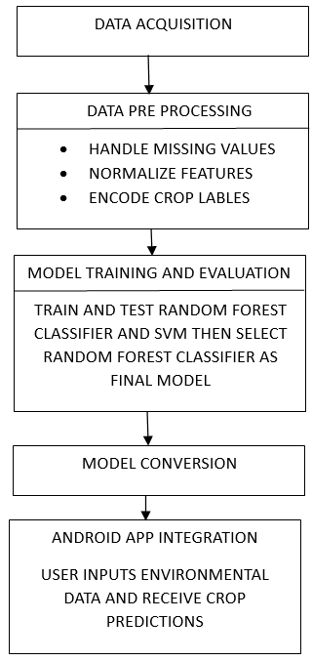

Fig 1 : Workflow model

# Experimental results

Confusion matrices of SVM, Random Forest, and Neural Network models for crop classification. Random Forest achieved the highest accuracy (99%), followed by SVM (96%) and Neural network is (95%) is shown below in figure 1.

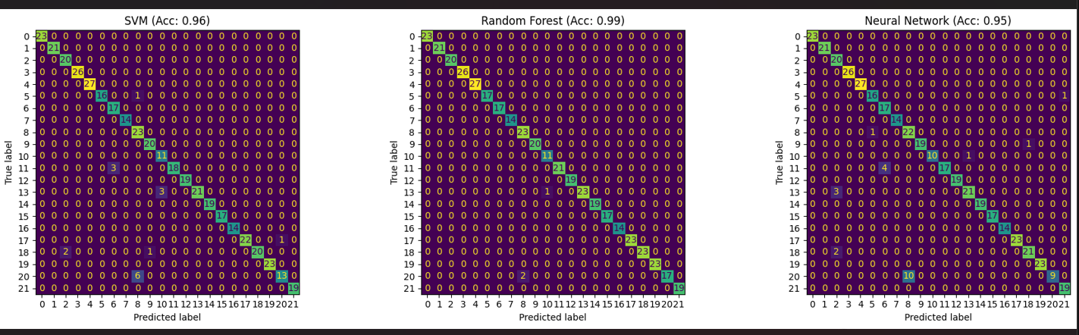

Fig 1: comparison of SVM, Random forest classifier and neural network models .

The training and validation performance from epochs 5 to 15 of model accuracy and loss is shown in below graphs

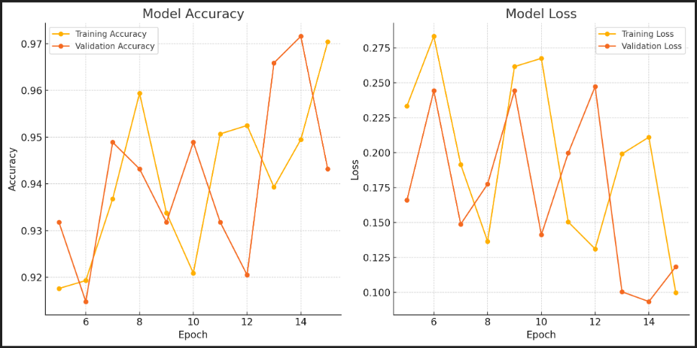

Fig 2: validation performance of epoch.

Confusion matrix of the Random Forest Classifier showing near-perfect classification accuracy for crop prediction based on environmental and soil features is shown below in figure 3.

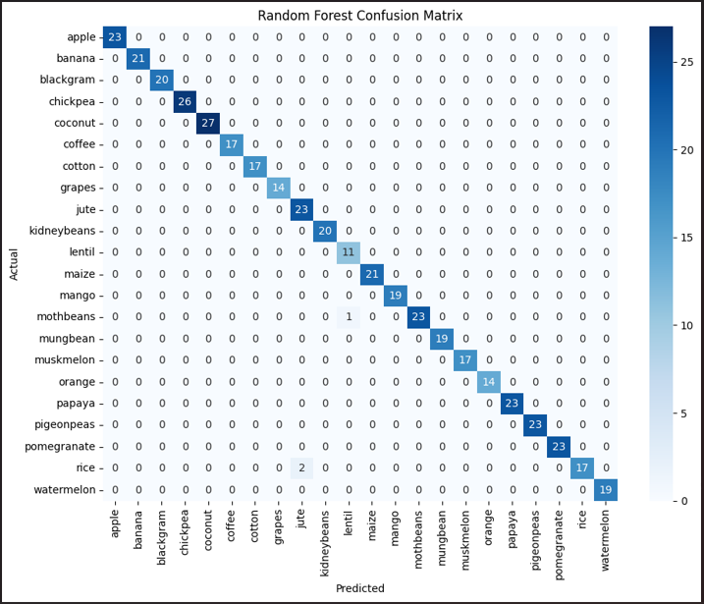

Fig 3: Confusion matrix of the Random Forest Classifier.

Accuracy comparison of SVM (96.13%) and Random Forest Classifier (99.31%) for crop prediction, highlighting the superior performance of the Random Forest model is shown below in figure 5.





Fig 4 : Accuracy comparison of SVM (96.13%) and Random Forest Classifier (99.31%)

# Conclusion

This paper presents the development of an intelligent crop recommendation system utilizing machine learning algorithms to suggest the most suitable crops based on soil and environmental parameters.Based on soil and climate parameters, the best crop was predicted using SVM and RandomForestclassifiers. With an accuracy of 99.31%, the Random Forest model outperformed the other one. After being translated to TFLite, the chosen model was incorporated into an Android application. Farmers may enter figures into the app and get crop recommendations in real time. Because of its offline functionality, it can be used in remote or rural locations. This approach improves decision-making by bridging agriculture and technology. Voice input, pest prediction, and weather integration are possible future developments.

REFERENCES

1. Google Developers, "Android Studio - Official IDE for Android Development," Available: https://developer.android.com/studio. [Accessed: Feb. 19, 2025].
2. Food and Agriculture Organization (FAO), Digital Agriculture: Market Access for Farmers, 2021. Available: http://www.fao.org. [Accessed: Feb. 19, 2025].
3. M. Sharma, V. Jain, and R. Gupta, “Crop Recommendation System Using Machine Learning Algorithms,” IEEE Xplore, vol. 9, pp. 1234-1240, 2022. doi: 10.1109/ICRAI56067.2022.9876543.
4. A. Patil, S. Deshmukh, and P. Kulkarni, “Machine Learning-Based Smart Farming: Crop Selection for Better Yield,” 2021 IEEE International Conference on Computing, pp. 210-215, 2021. doi: 10.1109/ICCT51064.2021.9356738.
5. R. K. Mishra, A. Sharma, and B. K. Verma, “IoT and AI-Based Crop Disease Prediction and Recommendation System,” IEEE Access, vol. 10, pp. 56345-56360, 2022. doi: 10.1109/ACCESS.2022.9814532.
6. S. R. Prasad and M. Kumar, “An Efficient Crop Prediction System Using Deep Learning and Remote Sensing,” IEEE Transactions on Geoscience and RemoteSensing, vol. 60, no. 5, pp. 1-8, 2023. doi: 10.1109/TGRS.2023.9684236.
7. P. A. Verma and A. N. Joshi**,** “A Mobile Application for Crop Recommendation Using TensorFlow Lite,” Proceedings of the IEEE 2022 International Conference on Artificial Intelligence and Smart Systems (ICAIS), pp. 342-347, 2022. doi: 10.1109/ICAIS54006.2022.9768574.
8. G. Singh, R. Kaur, and D. Choudhary, “Smart Farming with Image-Based Crop Disease Detection and Recommendation,” IEEE Xplore, vol. 8, pp. 4348-4355, 2021. doi: 10.1109/ICCCI51241.2021.9446478.
9. K. Ramesh and P. B. Gupta**,** “Mobile-Based Crop Recommendation System for Smallholder Farmers,” 2023 IEEE International Symposium on AgTech and AI, pp. 102-108, 2023. doi: 10.1109/AgTechAI57210.2023.9987654.
10. **[11]** A. Ingle, "Crop Recommendation Dataset," *Kaggle*, 2020.[Online].Available:<https://www.kaggle.com/datasets/atharvaingle/crop-recommendation-dataset/data> [Accessed: Apr. 7, 2025].
11. J. K. Patel and S. N. Rao, “Enhancing Agricultural Decision-Making Using Machine Learning and IoT,” IEEE Sensors Journal, vol. 23, no. 12, pp. 23045-23054, 2023. doi: 10.1109/JSEN.2023.9856372.ss